- IDENTITAS
NIM :
Nama Lengkap :
Kelas : D3 TI
Program Studi : D3 TEKNIK INFORMATIKA
Jurusan : TEKNIK INFORMATIKA

- HASIL PRAKTIKUM/ TUGAS
- Demo 1
- Kode Program
import java.awt.*;
import java.awt.event.ActionEvent;

import javax.swing.*;

import net.miginfocom.swing.MigLayout;

public class Demo1 extends JFrame {

private JPanel panelUtama;
private JButton buttonMulaiTask;
private JLabel labelStatus;
private JTextArea textAreaHasil;

public Demo1() {
initializeUI();
setupEventHandlers();
}

private void initializeUI() {
setTitle("Demo 1: UI Freeze");
setDefaultCloseOperation(JFrame.EXIT_ON_CLOSE);
setPreferredSize(new Dimension(560, 420));

panelUtama = new JPanel(
new MigLayout(
"fill, wrap 1, insets 20",
"[grow]"
)
);

buttonMulaiTask = new JButton("Mulai Task (8 detik)");
buttonMulaiTask.setFont(new Font("Inter", Font.BOLD, 18));
panelUtama.add(buttonMulaiTask, "growx, h 20%");

labelStatus = new JLabel("Status: Siap", JLabel.CENTER);
labelStatus.setFont(new Font("Inter", Font.PLAIN, 22));
labelStatus.setForeground(new Color(0, 102, 204));
panelUtama.add(labelStatus, "growx, h 20%");

textAreaHasil = new JTextArea(10, 50);
textAreaHasil.setEditable(false);
textAreaHasil.setFont(new Font("Consolas", Font.PLAIN, 15));
JScrollPane scroll = new JScrollPane(textAreaHasil);
panelUtama.add(scroll, "growx, h 60%");

add(panelUtama);
pack();
setLocationRelativeTo(null);
}

private void setupEventHandlers() {
buttonMulaiTask.addActionListener((ActionEvent e) -> {
buttonMulaiTask.setEnabled(false);
labelStatus.setText("Status: Sedang bekerja");
textAreaHasil.setText("Mengerjakan Background Task (8 detik)\n");

for (int i = 8; i >= 0; i--) {
final int seconds = i;
SwingUtilities.invokeLater(() -> {
textAreaHasil.append("Hitung mundur: " + seconds + "\n");
textAreaHasil.setCaretPosition(textAreaHasil.getDocument().getLength());
labelStatus.setText("Sisa " + seconds + " detik");
});

try {
Thread.sleep(1000);
} catch (InterruptedException ex) {
Thread.currentThread().interrupt();
}
}
textAreaHasil.append("Background Task selesai\n");
labelStatus.setText("Status: Selesai");
JOptionPane.showMessageDialog(
this,
"Background Task Selesai",
"Informasi",
JOptionPane.INFORMATION_MESSAGE
);
buttonMulaiTask.setEnabled(true);
});
}

public static void main(String[] args) {
SwingUtilities.invokeLater(() -> {
try {
UIManager.setLookAndFeel(UIManager.getSystemLookAndFeelClassName());
} catch (Exception e) { }

new Demo1().setVisible(true);

} );
}
}

- Hasil Run
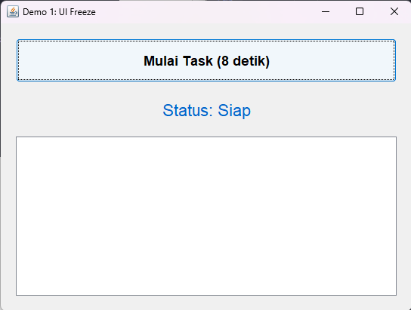
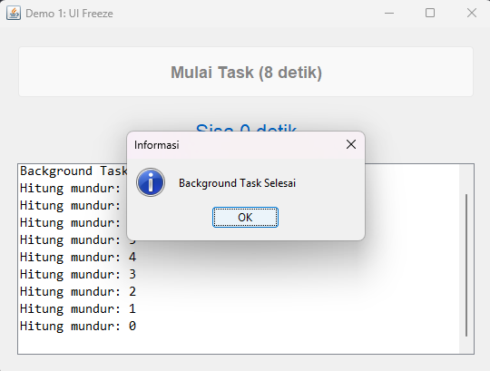
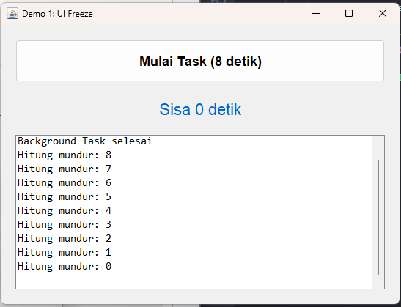
- Demo 2
- Kode Program
import java.awt.Color;
import java.awt.Dimension;
import java.awt.Font;
import java.util.List;

import javax.swing.JButton;
import javax.swing.JFrame;
import javax.swing.JLabel;
import javax.swing.JOptionPane;
import javax.swing.JPanel;
import javax.swing.JScrollPane;
import javax.swing.JTextArea;
import javax.swing.SwingUtilities;
import javax.swing.SwingWorker;
import javax.swing.UIManager;

import net.miginfocom.swing.MigLayout;

public class Demo2 extends JFrame {

private JPanel panelUtama;
private JButton buttonMulaiTask;
private JLabel labelStatus;
private JTextArea textAreaHasil;
private SwingWorker<String, Integer> worker;

public Demo2() {
initializeUI();
setupEventHandlers();
}

private void initializeUI() {
setTitle("Demo 2: SwingWorker (Anonymous Inner Class)");
setDefaultCloseOperation(JFrame.EXIT_ON_CLOSE);
setPreferredSize(new Dimension(600, 450));

panelUtama = new JPanel(
new MigLayout("fill, wrap 1, insets 20")
);

buttonMulaiTask = new JButton("Mulai Task (8 detik)");
buttonMulaiTask.setFont(new Font("Inter", Font.BOLD, 18));
panelUtama.add(buttonMulaiTask, "growx, h 20%");

labelStatus = new JLabel("Status: Siap", JLabel.CENTER);
labelStatus.setFont(new Font("Inter", Font.PLAIN, 22));
labelStatus.setForeground(new Color(0, 128, 0));
panelUtama.add(labelStatus, "growx, h 20%");

textAreaHasil = new JTextArea();
textAreaHasil.setEditable(false);
textAreaHasil.setFont(new Font("Consolas", Font.PLAIN, 15));
JScrollPane scroll = new JScrollPane(textAreaHasil);
panelUtama.add(scroll, "growx, h 60%");

add(panelUtama);
pack();
setLocationRelativeTo(null);
}

private void setupEventHandlers() {
buttonMulaiTask.addActionListener(e -> {
buttonMulaiTask.setEnabled(false);
labelStatus.setText("Status: Mulai bekerja");
textAreaHasil.setText("Mengerjakan Background Task (8 detik)\n");

worker = new SwingWorker<String, Integer>() {
@Override
protected String doInBackground() throws Exception {
for (int i = 8; i >= 0; i--) {
Thread.sleep(1000);
publish(i);
}
return "Background Task Selesai";
}

@Override
protected void process(List<Integer> chunks) {
int detik = chunks.get(chunks.size() - 1);
textAreaHasil.append("Hitung mundur: " + detik + "\n");
textAreaHasil.setCaretPosition(textAreaHasil.getDocument().getLength());
labelStatus.setText("Sisa " + detik + " detik");
}

@Override
protected void done() {
try {
String hasil = get();
textAreaHasil.append(hasil);
labelStatus.setText("Status: Selesai");
JOptionPane.showMessageDialog(
Demo2.this,
hasil,
"Informasi",
JOptionPane.INFORMATION_MESSAGE
);
} catch (Exception ex) {
labelStatus.setText("Status: Error");
} finally {
buttonMulaiTask.setEnabled(true);
}
}
};

worker.execute();
});
}

public static void main(String[] args) {
SwingUtilities.invokeLater(() -> {
try {
UIManager.setLookAndFeel(UIManager.getSystemLookAndFeelClassName());
} catch (Exception e) {
System.err.println(e.getMessage());
}
new Demo2().setVisible(true);
});
}
}

- Hasil Run
hijf
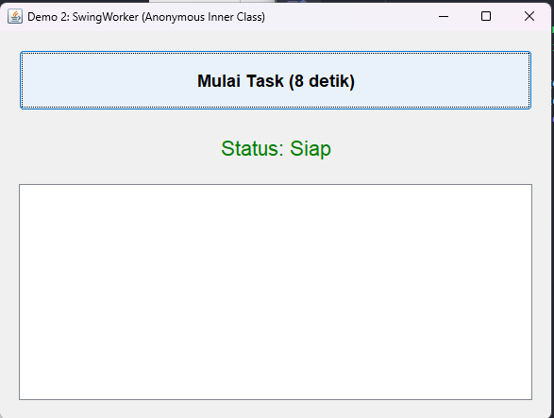
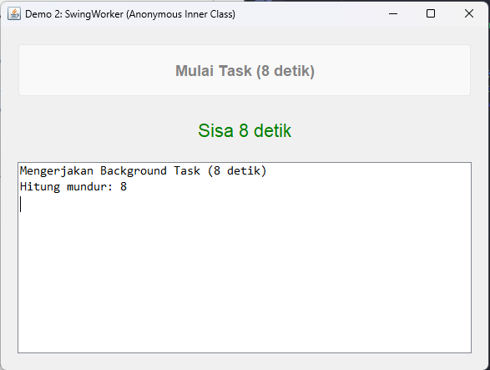
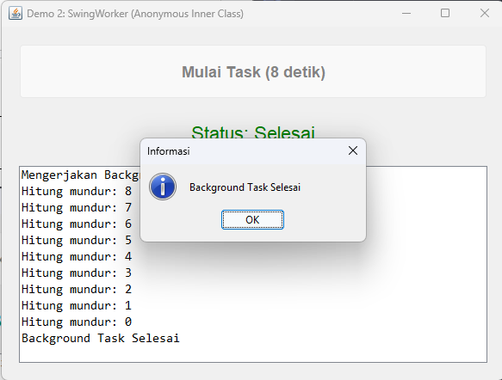

- Demo 3
- Kode Program
import java.awt.Color;
import java.awt.Dimension;
import java.awt.Font;
import java.util.List;

import javax.swing.JButton;
import javax.swing.JFrame;
import javax.swing.JLabel;
import javax.swing.JOptionPane;
import javax.swing.JPanel;
import javax.swing.JScrollPane;
import javax.swing.JTextArea;
import javax.swing.SwingUtilities;
import javax.swing.SwingWorker;
import javax.swing.UIManager;

import net.miginfocom.swing.MigLayout;

public class Demo3 extends JFrame {

private JPanel panelUtama;
private JButton buttonMulaiTask;
private JLabel labelStatus;
private JTextArea textAreaHasil;

public Demo3() {
initializeUI();
setupEventHandlers();
}

private void initializeUI() {
setTitle("Demo 3: SwingWorker (Static Nested Class)");
setDefaultCloseOperation(JFrame.EXIT_ON_CLOSE);
setPreferredSize(new Dimension(600, 450));

panelUtama = new JPanel(
new MigLayout("fill, wrap 1, insets 20")
);

buttonMulaiTask = new JButton("Mulai Task (8 detik)");
buttonMulaiTask.setFont(new Font("Inter", Font.BOLD, 18));
panelUtama.add(buttonMulaiTask, "growx, h 20%");

labelStatus = new JLabel("Status: Siap", JLabel.CENTER);
labelStatus.setFont(new Font("Inter", Font.PLAIN, 22));
labelStatus.setForeground(new Color(0, 128, 0));
panelUtama.add(labelStatus, "growx, h 20%");

textAreaHasil = new JTextArea();
textAreaHasil.setEditable(false);
textAreaHasil.setFont(new Font("Consolas", Font.PLAIN, 15));
JScrollPane scroll = new JScrollPane(textAreaHasil);
panelUtama.add(scroll, "growx, h 60%");

add(panelUtama);
pack();
setLocationRelativeTo(null);
}

private void setupEventHandlers() {
buttonMulaiTask.addActionListener(
e -> new HitungMundurWorker(this).execute()
);
}

private static class HitungMundurWorker extends SwingWorker<String, Integer> {
private final Demo3 frame;

private HitungMundurWorker(Demo3 frame) {
this.frame = frame;
}

@Override
protected String doInBackground() throws Exception {
frame.buttonMulaiTask.setEnabled(false);
frame.labelStatus.setText("Status: Mulai bekerja");
frame.textAreaHasil.setText("Mengerjakan Background Task (8 detik)\n");

for (int i = 8; i >= 0; i--) {
Thread.sleep(1000);
publish(i);
}
return "Background Task Selesai";
}

@Override
protected void process(List<Integer> chunks) {
int detik = chunks.get(chunks.size() - 1);
frame.textAreaHasil.append("Hitung mundur: " + detik + "\n");
frame.textAreaHasil.setCaretPosition(frame.textAreaHasil.getDocument().getLength());
frame.labelStatus.setText("Sisa " + detik + " detik");
}

@Override
protected void done() {
try {
String hasil = get();
frame.textAreaHasil.append(hasil);
frame.labelStatus.setText("Status: Selesai");
JOptionPane.showMessageDialog(frame, hasil, "Informasi", JOptionPane.INFORMATION_MESSAGE);
} catch (Exception ex) {
frame.labelStatus.setText("Status: Error");
} finally {
frame.buttonMulaiTask.setEnabled(true);
}
}
}

public static void main(String[] args) {
SwingUtilities.invokeLater(() -> {
try {
UIManager.setLookAndFeel(UIManager.getSystemLookAndFeelClassName());
} catch (Exception e) {
System.err.println(e.getMessage());
}
new Demo3().setVisible(true);
});
}
}

- Hasil Run
hiji
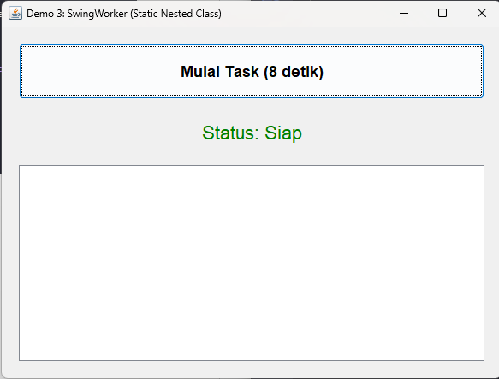
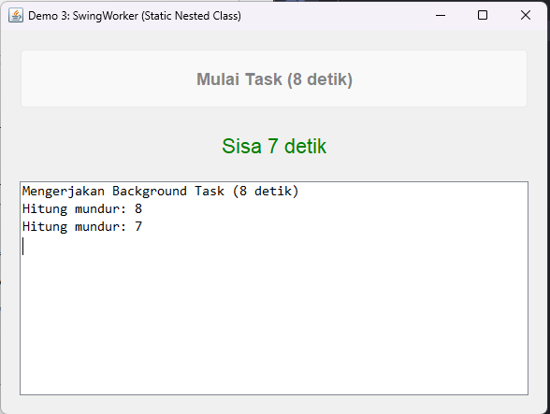
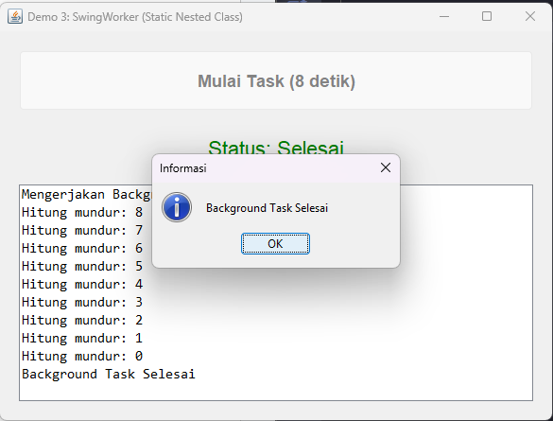
- Demo 4
- Kode Program
jdfi

- Hasil Run
- Demo 4 B
- Demo 5

